Kinematics
KINEMATICS DERIVES ITS NAME FROM the Greek word for “motion,” kinema. Before we can make any headway in physics, we have to be able to describe how bodies move. Kinematics provides us with the language and the mathematical tools to describe motion, whether the motion of a charging pachyderm or a charged particle. As such, it provides a foundation that will help us in all areas of physics. Kinematics is most intimately connected with dynamics: while kinematics describes motion, dynamics explains the causes for this motion.

Displacement
Displacement is a vector quantity, commonly denoted by the vector s, that reflects an object’s change in spatial position. The displacement of an object that moves from point A to point B is a vector whose tail is at A and whose tip is at B. Displacement deals only with the separation between points A and B, and not with the path the object followed between points A and B. By contrast, the distance that the object travels is equal to the length of path AB.
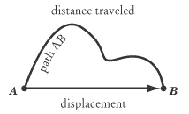
Students often mistake displacement for distance, and SAT II Physics may well call for you to distinguish between the two. A question favored by test makers everywhere is to ask the displacement of an athlete who has run a lap on a 400-meter track. The answer, of course, is zero: after running a lap, the athlete is back where he or she started. The distance traveled by the athlete, and not the displacement, is 400 meters.
EXAMPLE
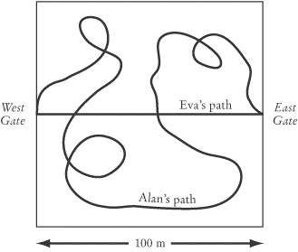
Alan and Eva are walking through a beautiful garden. Because Eva is very worried about the upcoming SAT II Physics Test, she takes no time to smell the flowers and instead walks on a straight path from the west garden gate to the east gate, a distance of 100 meters. Alan, unconcerned about the test, meanders off the straight path to smell all the flowers in sight. When Alan and Eva meet at the east gate, who has walked a greater distance? What are their displacements?

Since Eva took the direct path between the west and east garden gates and Alan took an indirect path, Alan has traveled a much greater distance than Eva. Yet, as we have discussed, displacement is a vector quantity that measures the distance separating the starting point from the ending point: the path taken between the two points is irrelevant. So Alan and Eva both have the same displacement: 100 meters east of the west gate. Note that, because displacement is a vector quantity, it is not enough to say that the displacement is 100 meters: you must also state the direction of that displacement. The distance that Eva has traveled is exactly equal to the magnitude of her displacement: 100 meters.
After reaching the east gate, Eva and Alan notice that the gate is locked, so they must turn around and exit the garden through the west gate. On the return trip, Alan again wanders off to smell the flowers, and Eva travels the path directly between the gates. At the center of the garden, Eva stops to throw a penny into a fountain. At this point, what is her displacement from her starting point at the west gate?

Eva is now 50 meters from the west gate, so her displacement is 50 meters, even though she has traveled a total distance of 150 meters.
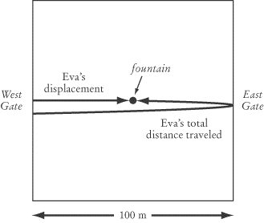
When Alan and Eva reconvene at the west gate, their displacements are both zero, as they both began and ended their garden journey at the west gate. The moral of the story? Always take time to smell the flowers!

Speed, Velocity, and Acceleration
Along with displacement, velocity and acceleration round out the holy trinity of kinematics. As you’ll see, all three are closely related to one another, and together they offer a pretty complete understanding of motion. Speed, like distance, is a scalar quantity that won’t come up too often on SAT II Physics, but it might trip you up if you don’t know how to distinguish it from velocity.
Speed and Velocity
As distance is to displacement, so speed is to velocity: the crucial difference between the two is that speed is a scalar and velocity is a vector quantity. In everyday conversation, we usually say speed when we talk about how fast something is moving. However, in physics, it is often important to determine the direction of this motion, so you’ll find velocity come up in physics problems far more frequently than speed.
A common example of speed is the number given by the speedometer in a car. A speedometer tells us the car’s speed, not its velocity, because it gives only a number and not a direction. Speed is a measure of the distance an object travels in a given length of time:
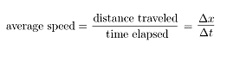
Velocity is a vector quantity defined as rate of change of the displacement vector over time:
average velocity = 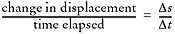
It is important to remember that the average speed and the magnitude of the average velocity may not be equivalent.
Instantaneous Speed and Velocity
The two equations given above for speed and velocity discuss only the average speed and average velocity over a given time interval. Most often, as with a car’s speedometer, we are not interested in an average speed or velocity, but in the instantaneous velocity or speed at a given moment. That is, we don’t want to know how many meters an object covered in the past ten seconds; we want to know how fast that object is moving right now. Instantaneous velocity is not a tricky concept: we simply take the equation above and assume that is very, very small.
Most problems on SAT II Physics ask about an object’s instantaneous velocity rather than its average velocity or speed over a given time frame. Unless a question specifically asks you about the average velocity or speed over a given time interval, you can safely assume that it is asking about the instantaneous velocity at a given moment.
EXAMPLE
 | Which of the follow sentences contains an example of instantaneous velocity?
 | (A) | “The car covered 500 kilometers in the first 10 hours of its northward journey.”
 | (B) | “Five seconds into the launch, the rocket was shooting upward at 5000 meters per second.”
 | (C) | “The cheetah can run at 70 miles per hour.”
 | (D) | “Moving at five kilometers per hour, it will take us eight hours to get to the base camp.”
 | (E) | “Roger Bannister was the first person to run one mile in less than four minutes.”

Instantaneous velocity has a magnitude and a direction, and deals with the velocity at a particular instant in time. All three of these requirements are met only in B. A is an example of average velocity, C is an example of instantaneous speed, and both D and E are examples of average speed.
Acceleration
Speed and velocity only deal with movement at a constant rate. When we speed up, slow down, or change direction, we want to know our acceleration. Acceleration is a vector quantity that measures the rate of change of the velocity vector with time:
average acceleration = 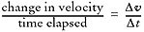
Applying the Concepts of Speed, Velocity, and Acceleration
With these three definitions under our belt, let’s apply them to a little story of a zealous high school student called Andrea. Andrea is due to take SAT II Physics at the ETS building 10 miles due east from her home. Because she is particularly concerned with sleeping as much as possible before the test, she practices the drive the day before so she knows exactly how long it will take and how early she must get up.
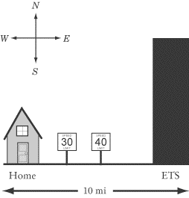
Instantaneous Velocity
After starting her car, she zeros her odometer so that she can record the exact distance to the test center. Throughout the drive, Andrea is cautious of her speed, which is measured by her speedometer. At first she is careful to drive at exactly 30 miles per hour, as advised by the signs along the road. Chuckling to herself, she notes that her instantaneous velocity—a vector quantity—is 30 miles per hour due east.
Average Acceleration
Along the way, Andrea sees a new speed limit sign of 40 miles per hour, so she accelerates. Noting with her trusty wristwatch that it takes her two seconds to change from 30 miles per hour due east to 40 miles per hour due east, Andrea calculates her average acceleration during this time frame:
average acceleration = 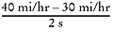
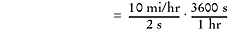
This may seem like an outrageously large number, but in terms of meters per second squared, the standard units for measuring acceleration, it comes out to 0.22 m/s2.
Average Velocity: One Way
After reaching the tall, black ETS skyscraper, Andrea notes that the test center is exactly 10 miles from her home and that it took her precisely 16 minutes to travel between the two locations. She does a quick calculation to determine her average velocity during the trip:

Average Speed and Velocity: Return Journey
Satisfied with her little exercise, Andrea turns the car around to see if she can beat her 16-minute time. Successful, she arrives home without a speeding ticket in 15 minutes. Andrea calculates her average speed for the entire journey to ETS and back home:

Is this the same as her average velocity? Andrea reminds herself that, though her odometer reads 20 miles, her net displacement—and consequently her average velocity over the entire length of the trip—is zero. SAT II Physics is not going to get her with any trick questions like that!

Kinematics with Graphs
Since you are not allowed to use calculators, SAT II Physics places a heavy emphasis on qualitative problems. A common way of testing kinematics qualitatively is to present you with a graph plotting position vs. time, velocity vs. time, or acceleration vs. time and to ask you questions about the motion of the object represented by the graph. Because SAT II Physics is entirely made up of multiple-choice questions, you won’t need to know how to draw graphs; you’ll just have to interpret the data presented in them.
Knowing how to read such graphs quickly and accurately will not only help you solve problems of this sort, it will also help you visualize the often-abstract realm of kinematic equations. In the examples that follow, we will examine the movement of an ant running back and forth along a line.
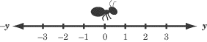
Position vs. Time Graphs
Position vs. time graphs give you an easy and obvious way of determining an object’s displacement at any given time, and a subtler way of determining that object’s velocity at any given time. Let’s put these concepts into practice by looking at the following graph charting the movements of our friendly ant.
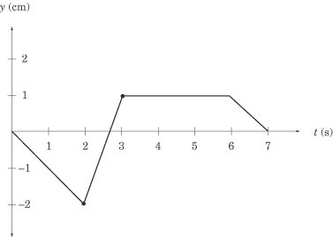
Any point on this graph gives us the position of the ant at a particular moment in time. For instance, the point at (2,–2) tells us that, two seconds after it started moving, the ant was two centimeters to the left of its starting position, and the point at (3,1)tells us that, three seconds after it started moving, the ant is one centimeter to the right of its starting position.
Let’s read what the graph can tell us about the ant’s movements. For the first two seconds, the ant is moving to the left. Then, in the next second, it reverses its direction and moves quickly to y = 1. The ant then stays still at y = 1 for three seconds before it turns left again and moves back to where it started. Note how concisely the graph displays all this information.
Calculating Velocity
We know the ant’s displacement, and we know how long it takes to move from place to place. Armed with this information, we should also be able to determine the ant’s velocity, since velocity measures the rate of change of displacement over time. If displacement is given here by the vector y, then the velocity of the ant is
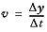
If you recall, the slope of a graph is a measure of rise over run; that is, the amount of change in the y direction divided by the amount of change in the x direction. In our graph, is the change in the y direction and is the change in the x direction, so vis a measure of the slope of the graph. For any position vs. time graph, the velocity at time t is equal to the slope of the line at t. In a graph made up of straight lines, like the one above, we can easily calculate the slope at each point on the graph, and hence know the instantaneous velocity at any given time.
We can tell that the ant has a velocity of zero from t = 3 to t = 6, because the slope of the line at these points is zero. We can also tell that the ant is cruising along at the fastest speed between t = 2 and t = 3, because the position vs. time graph is steepest between these points. Calculating the ant’s average velocity during this time interval is a simple matter of dividing rise by run, as we’ve learned in math class.
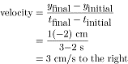
Average Velocity
How about the average velocity between t = 0 and t = 3? It’s actually easier to sort this out with a graph in front of us, because it’s easy to see the displacement at t = 0 and t = 3, and so that we don’t confuse displacement and distance.
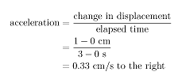
Average Speed
Although the total displacement in the first three seconds is one centimeter to the right, the total distance traveled is two centimeters to the left, and then three centimeters to the right, for a grand total of five centimeters. Thus, the average speed is not the same as the average velocity of the ant. Once we’ve calculated the total distance traveled by the ant, though, calculating its average speed is not difficult:
Curved Position vs. Time Graphs
This is all well and good, but how do you calculate the velocity of a curved position vs. time graph? Well, the bad news is that you’d need calculus. The good news is that SAT II Physics doesn’t expect you to use calculus, so if you are given a curved position vs. time graph, you will only be asked qualitative questions and won’t be expected to make any calculations. A few points on the graph will probably be labeled, and you will have to identify which point has the greatest or least velocity. Remember, the point with the greatest slope has the greatest velocity, and the point with the least slope has the least velocity. The turning points of the graph, the tops of the “hills” and the bottoms of the “valleys” where the slope is zero, have zero velocity.
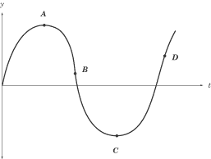
In this graph, for example, the velocity is zero at points A and C, greatest at point D, and smallest at point B. The velocity at point B is smallest because the slope at that point is negative. Because velocity is a vector quantity, the velocity at B would be a large negative number. However, the speed at B is greater even than the speed at D: speed is a scalar quantity, and so it is always positive. The slope at B is even steeper than at D, so the speed is greatest at B.
Velocity vs. Time Graphs
Velocity vs. time graphs are the most eloquent kind of graph we’ll be looking at here. They tell us very directly what the velocity of an object is at any given time, and they provide subtle means for determining both the position and acceleration of the same object over time. The “object” whose velocity is graphed below is our ever-industrious ant, a little later in the day.
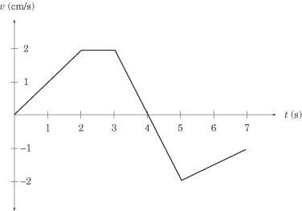
We can learn two things about the ant’s velocity by a quick glance at the graph. First, we can tell exactly how fast it is going at any given time. For instance, we can see that, two seconds after it started to move, the ant is moving at 2 cm/s. Second, we can tell in which direction the ant is moving. From t = 0 to t = 4, the velocity is positive, meaning that the ant is moving to the right. From t = 4 to t = 7, the velocity is negative, meaning that the ant is moving to the left.
Calculating Acceleration
We can calculate acceleration on a velocity vs. time graph in the same way that we calculate velocity on a position vs. time graph. Acceleration is the rate of change of the velocity vector, , which expresses itself as the slope of the velocity vs. time graph. For a velocity vs. time graph, the acceleration at time t is equal to the slope of the line at t.
What is the acceleration of our ant at t = 2.5 and t = 4? Looking quickly at the graph, we see that the slope of the line at t = 2.5 is zero and hence the acceleration is likewise zero. The slope of the graph between t = 3 and t = 5 is constant, so we can calculate the acceleration at t = 4 by calculating the average acceleration between t = 3 and t = 5:
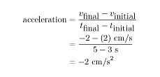
The minus sign tells us that acceleration is in the leftward direction, since we’ve defined the y-coordinates in such a way that right is positive and left is negative. At t = 3, the ant is moving to the right at 2 cm/s, so a leftward acceleration means that the ant begins to slow down. Looking at the graph, we can see that the ant comes to a stop at t = 4, and then begins accelerating to the right.
Calculating Displacement
Velocity vs. time graphs can also tell us about an object’s displacement. Because velocity is a measure of displacement over time, we can infer that:
Graphically, this means that the displacement in a given time interval is equal to the area under the graph during that same time interval. If the graph is above the t-axis, then the positive displacement is the area between the graph and the t-axis. If the graph is below the t-axis, then the displacement is negative, and is the area between the graph and the t-axis. Let’s look at two examples to make this rule clearer.
First, what is the ant’s displacement between t = 2 and t = 3? Because the velocity is constant during this time interval, the area between the graph and the t-axis is a rectangle of width 1 and height 2.
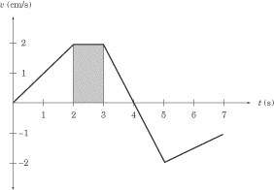
The displacement between t = 2 and t = 3 is the area of this rectangle, which is 1 cm/ss = 2 cm to the right.
Next, consider the ant’s displacement between t = 3 and t = 5. This portion of the graph gives us two triangles, one above the t-axis and one below the t-axis.
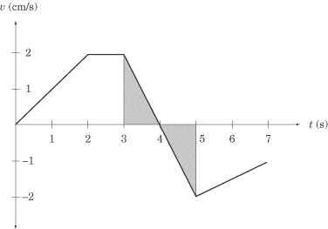
Both triangles have an area of 1 /2(1 s)(2 cm/s) = 1 cm. However, the first triangle is above the t-axis, meaning that displacement is positive, and hence to the right, while the second triangle is below the t-axis, meaning that displacement is negative, and hence to the left. The total displacement between t = 3 and t = 5 is:
In other words, at t = 5, the ant is in the same place as it was at t = 3.
Curved Velocity vs. Time Graphs
As with position vs. time graphs, velocity vs. time graphs may also be curved. Remember that regions with a steep slope indicate rapid acceleration or deceleration, regions with a gentle slope indicate small acceleration or deceleration, and the turning points have zero acceleration.
Acceleration vs. Time Graphs
After looking at position vs. time graphs and velocity vs. time graphs, acceleration vs. time graphs should not be threatening. Let’s look at the acceleration of our ant at another point in its dizzy day.
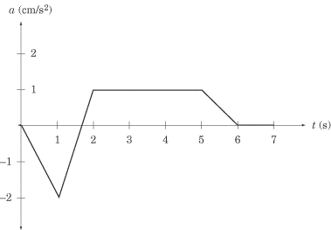
Acceleration vs. time graphs give us information about acceleration and about velocity. SAT II Physics generally sticks to problems that involve a constant acceleration. In this graph, the ant is accelerating at 1 m/s2 from t = 2 to t = 5 and is not accelerating between t = 6 and t = 7; that is, between t = 6 and t = 7 the ant’s velocity is constant.
Calculating Change in Velocity
Acceleration vs. time graphs tell us about an object’s velocity in the same way that velocity vs. time graphs tell us about an object’s displacement. The change in velocity in a given time interval is equal to the area under the graph during that same time interval. Be careful: the area between the graph and the t-axis gives the change in velocity, not the final velocity or average velocity over a given time period.
What is the ant’s change in velocity between t = 2 and t = 5? Because the acceleration is constant during this time interval, the area between the graph and the t-axis is a rectangle of height 1 and length 3.
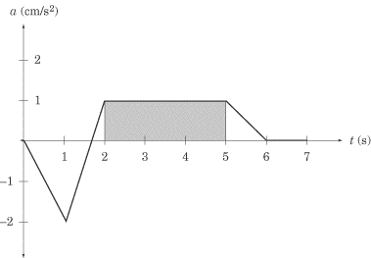
The area of the shaded region, and consequently the change in velocity during this time interval, is 1 cm/s2 · 3 s = 3 cm/s to the right. This doesn’t mean that the velocity at t = 5 is 3 cm/s; it simply means that the velocity is 3 cm/s greater than it was at t = 2. Since we have not been given the velocity at t = 2, we can’t immediately say what the velocity is at t = 5.
Summary of Rules for Reading Graphs
You may have trouble recalling when to look for the slope and when to look for the area under the graph. Here are a couple handy rules of thumb:
- The slope on a given graph is equivalent to the quantity we get by dividing the y-axis by the x-axis. For instance, the y-axis of a position vs. time graph gives us displacement, and the x-axis gives us time. Displacement divided by time gives us velocity, which is what the slope of a position vs. time graph represents.
- The area under a given graph is equivalent to the quantity we get by multiplying the x-axis and the y-axis. For instance, the y-axis of an acceleration vs. time graph gives us acceleration, and the x-axis gives us time. Acceleration multiplied by time gives us the change in velocity, which is what the area between the graph and the x-axis represents.
We can summarize what we know about graphs in a table:
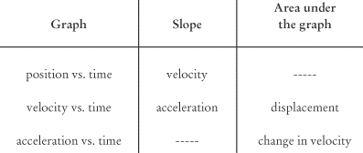

One-Dimensional Motion with Uniform Acceleration
Many introductory physics problems can be simplified to the special case of uniform motion in one dimension with constant acceleration. That is, most problems will involve objects moving in a straight line whose acceleration doesn’t change over time. For such problems, there are five variables that are potentially relevant: the object’s position, x; the object’s initial velocity, ; the object’s final velocity, v; the object’s acceleration, a; and the elapsed time, t. If you know any three of these variables, you can solve for a fourth. Here are the five kinematic equations that you should memorize and hold dear to your heart:

The variable represents the object’s position at t = 0. Usually, = 0.
You’ll notice there are five equations, each of which contain four of the five variables we mentioned above. In the first equation, a is missing; in the second, x is missing; in the third, v is missing; in the fourth, is missing; and in the fifth, t is missing. You’ll find that in any kinematics problem, you will know three of the five variables, you’ll have to solve for a fourth, and the fifth will play no role in the problem. That means you’ll have to choose the equation that doesn’t contain the variable that is irrelavent to the problem.
Learning to Read Verbal Clues
Problems will often give you variables like t or x, and then give you verbal clues regarding velocity and acceleration. You have to learn to translate such phrases into kinematics-equation-speak:
When They Say . . . | They Mean . . .
“. . . starts from rest . . .”
“. . . moves at a constant velocity . . .” | a = 0
“. . . comes to rest . . . ” | v = 0
Very often, problems in kinematics on SAT II Physics will involve a body falling under the influence of gravity. You’ll find people throwing balls over their heads, at targets, and even off the Leaning Tower of Pisa. Gravitational motion is uniformly accelerated motion: the only acceleration involved is the constant pull of gravity, –9.8 m/s2 toward the center of the Earth. When dealing with this constant, called g, it is often convenient to round it off to –10 m/s2.
EXAMPLE
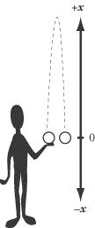
A student throws a ball up in the air with an initial velocity of 12 m/s and then catches it as it comes back down to him. What is the ball’s velocity when he catches it? How high does the ball travel? How long does it take the ball to reach its highest point?

Before we start writing down equations and plugging in numbers, we need to choose a coordinate system. This is usually not difficult, but it is vitally important. Let’s make the origin of the system the point where the ball is released from the student’s hand and begins its upward journey, and take the up direction to be positive and the down direction to be negative.
We could have chosen other coordinate systems—for instance, we could have made the origin the ground on which the student is standing—but our choice of coordinate system is convenient because in it, = 0, so we won’t have to worry about plugging a value for into our equation. It’s usually possible, and a good idea, to choose a coordinate system that eliminates . Choosing the up direction as positive is simply more intuitive, and thus less likely to lead us astray. It’s generally wise also to choose your coordinate system so that more variables will be positive numbers than negative ones, simply because positive numbers are easier to deal with.
WHAT IS THE BALL’S VELOCITY WHEN HE CATCHES IT?
We can determine the answer to this question without any math at all. We know the initial velocity, m/s, and the acceleration due to gravity, m/s2, and we know that the displacement is x = 0 since the ball’s final position is back in the student’s hand where it started. We need to know the ball’s final velocity, v, so we should look at the kinematic equation that leaves out time, t:
Because both x and are zero, the equation comes out to But don’t be hasty and give the answer as 12 m/s: remember that we devised our coordinate system in such a way that the down direction is negative, so the ball’s final velocity is –12 m/s.
HOW HIGH DOES THE BALL TRAVEL?
We know that at the top of the ball’s trajectory its velocity is zero. That means that we know that = 12 m/s, v = 0, and m/s2, and we need to solve for x:
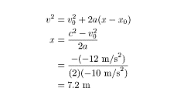
HOW LONG DOES IT TAKE THE BALL TO REACH ITS HIGHEST POINT?
Having solved for x at the highest point in the trajectory, we now know all four of the other variables related to this point, and can choose any one of the five equations to solve for t. Let’s choose the one that leaves out x:

Note that there are certain convenient points in the ball’s trajectory where we can extract a third variable that isn’t mentioned explicitly in the question: we know that x= 0 when the ball is at the level of the student’s hand, and we know that v = 0 at the top of the ball’s trajectory.

Two-Dimensional Motion with Uniform Acceleration
If you’ve got the hang of 1-D motion, you should have no trouble at all with 2-D motion. The motion of any object moving in two dimensions can be broken into x- and y-components. Then it’s just a matter of solving two separate 1-D kinematic equations.
The most common problems of this kind on SAT II Physics involve projectile motion: the motion of an object that is shot, thrown, or in some other way launched into the air. Note that the motion or trajectory of a projectile is a parabola.
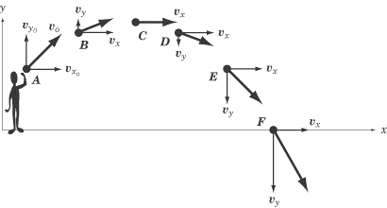
If we break this motion into x- and y-components, the motion becomes easy to understand. In the y direction, the ball is thrown upward with an initial velocity of and experiences a constant downward acceleration of g = –9.8 m/s2. This is exactly the kind of motion we examined in the previous section: if we ignore the x-component, the motion of a projectile is identical to the motion of an object thrown directly up in the air.
In the x direction, the ball is thrown forward with an initial velocity of and there is no acceleration acting in the x direction to change this velocity. We have a very simple situation where and is constant.
SAT II Physics will probably not expect you to do much calculating in questions dealing with projectile motion. Most likely, it will ask about the relative velocity of the projectile at different points in its trajectory. We can calculate the x- and y-components separately and then combine them to find the velocity of the projectile at any given point:
Because is constant, the speed will be greater or lesser depending on the magnitude of . To determine where the speed is least or greatest, we follow the same method as we would with the one-dimensional example we had in the previous section. That means that the speed of the projectile in the figure above is at its greatest at position F, and at its least at position C. We also know that the speed is equal at position B and position D, and at position A and position E.
The key with two-dimensional motion is to remember that you are not dealing with one complex equation of motion, but rather with two simple equations.

Key Formulas
Average Speed | average speed = 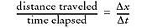
Average Velocity | average velocity = 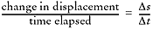
Average Acceleration | average acceleration = 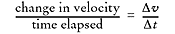
One-Dimensional Motion with Uniform Acceleration (a.k.a. “The Five Kinematic Equations”)
Velocity of Two-Dimensional Projectiles

Practice Questions
1. | An athlete runs four laps of a 400 m track. What is the athlete’s total displacement?
 | (A) | –1600 m
 | (B) | –400 m
 | (C) | 0 m
 | (D) | 400 m
 | (E) | 1600 m

2. | Which of the following statements contains a reference to displacement?
I. “The town is a five mile drive along the winding country road.”
II. “The town sits at an altitude of 940 m.”
III. “The town is ten miles north, as the crow flies.”
 | (A) | I only
 | (B) | III only
 | (C) | I and III only
 | (D) | II and III only
 | (E) | I, II, and III

Questions 3 and 4 refer to a car that travels from point A to point B in four hours, and then from point B back to point A in six hours. The road between point A and point B is perfectly straight, and the distance between the two points is 240 km.
3. | What is the car’s average velocity?
 | (A) | 0 km/h
 | (B) | 48 km/h
 | (C) | 50 km/h
 | (D) | 60 km/h
 | (E) | 100 km/h

4. | What is the car’s average speed?
 | (A) | 0 km/h
 | (B) | 48 km/h
 | (C) | 50 km/h
 | (D) | 60 km/h
 | (E) | 100 km/h

5. | A ball is dropped from the top of a building. Taking air resistance into account, which best describes the speed of the ball while it is moving downward?
 | (A) | It will increase until it reaches the speed of light
 | (B) | It will increase at a steady rate
 | (C) | It will remain constant
 | (D) | It will decrease
 | (E) | Its rate of acceleration will decrease until the ball moves at a constant speed

6. | A car accelerates steadily so that it goes from a velocity of 20 m/s to a velocity of 40 m/s in 4 seconds. What is its acceleration?
 | (A) | 0.2 m/s2
 | (B) | 4 m/s2
 | (C) | 5 m/s2
 | (D) | 10 m/s2
 | (E) | 80 m/s2

Questions 7 and 8 relate to the graph of velocity vs. time of a moving particle plotted at right.
 | 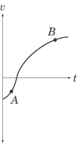
7. | What is the acceleration and displacement of the particle at point A?
 | (A) | Acceleration decreasing, displacement decreasing
 | (B) | Acceleration constant, displacement decreasing
 | (C) | Acceleration increasing, displacement decreasing
 | (D) | Acceleration decreasing, displacement increasing
 | (E) | Acceleration increasing, displacement increasing

8. | How do the acceleration and displacement of the particle at point B compare to the acceleration and displacement of the particle at point A?
 | (A) | Acceleration is less, displacement is less
 | (B) | Acceleration is less, displacement is the same
 | (C) | Acceleration is less, displacement is greater
 | (D) | Acceleration is greater, displacement is less
 | (E) | Acceleration is greater, displacement is greater

9. | A sprinter starts from rest and accelerates at a steady rate for the first 50 m of a 100 m race, and then continues at a constant velocity for the second 50 m of the race. If the sprinter runs the 100 m in a time of 10 s, what is his instantaneous velocity when he crosses the finish line?
 | (A) | 5 m/s
 | (B) | 10 m/s
 | (C) | 12 m/s
 | (D) | 15 m/s
 | (E) | 20 m/s

10. | A woman runs 40 m to the north in 6.0 s, and then 30 m to the east in 4.0Â s. What is the magnitude of her average velocity?
 | (A) | 5.0 m/s
 | (B) | 6.0 m/s
 | (C) | 6.7 m/s
 | (D) | 7.0 m/s
 | (E) | 7.5 m/s

Explanations
1. C
Displacement is a vector quantity that measures the distance between the starting point and ending point, not taking the actual path traveled into account. At the end of four laps, the athlete will be back at the starting line for the track, so the athlete’s total displacement will be zero.
2. D
Statement I refers to distance, not displacement, since the five-mile distance is along a winding road and does not describe a straight-line path.
Both statements II and III, however, contain a reference to displacement. The altitude of a town is a measure of the straight-line distance between the town and sea level. “As the crow flies” is a common way of saying “in a straight-line path.” Neither statement II nor statement III describes a certain route between the two points in question: they simply describe how far apart those two points are.
3. A
Average velocity is a measure of total displacement divided by total time. Total displacement is the distance separating the starting point and the finishing point. Since the car both starts and finishes at point A, its total displacement is zero, so its average velocity is also zero.
4. B
Average speed is a measure of total distance traveled divided by the total time of the trip. Solving this problem calls for a single calculation:

5. E
The force of air resistance against a ball increases as the ball accelerates. At a certain point, the force of air resistance will be equal to the force of gravity, and the net force acting on the ball will be zero. At this point, its velocity will remain constant. This velocity is known as an object’s “terminal velocity,” and it explains why, in real life, many falling objects don’t continue accelerating all the way to the ground.
6. C
Acceleration is a measure of the change in velocity over time. The car’s change in velocity is 40 – 20 = 20 m/s. Since this change in velocity takes place over 4 seconds, the car’s acceleration is
7. C
Point A is below the t-axis, which means that the velocity is negative. Since velocity is the change in displacement over time, we can conclude that if the velocity is negative, then the displacement is decreasing.
Acceleration is given by the slope of the graph. Since the line at point A has a positive slope, we know that the acceleration is increasing.
8. C
Acceleration is given by the slope of the line. As we can see, the slope is greater at point A than at point B, so the acceleration is less at point B.
The change in displacement is given by the area between the graph and the t-axis:
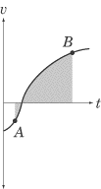
As we can see, between points A and B, a great deal more of the graph is above the t-axis than below it. This means that, overall, displacement is positive between these two points.
9. D
We know the total distance the sprinter covers, and we know the total time. However, since the acceleration isn’t uniform, we can’t calculate the velocity quite so simply. Rather, we need two equations, one for the first 50 meters of the race, and another for the second 50 meters. In the first 50 meters, the sprinter accelerates from an initial velocity of to a final velocity of v in an amount of time, . We can express this relationship using the kinematic equation that leaves out velocity, and then solve for t:

In the last 50 meters of the race, the sprinter runs with a constant velocity of v, covering a distance of x = 50 m in a time . Solving for , we find:
We know that the total time of the race, s. With this in mind, we can add the two sprint times together and solve for v:

10. A
Average velocity is given by the total displacement divided by the total time elapsed. The displacement is not simply 30 + 40 = 70 m, however, since the woman doesn’t run in a straight-line path. The 40 m north and the 30 m east are at right angles to one another, so we can use the Pythagorean Theorem to determine that the total displacement is in fact 50 m. Her displacement is 50 m over a total time of 10 s, so her average velocity is 5.0 m/s.

